**Christians Helping Raise India's Students**

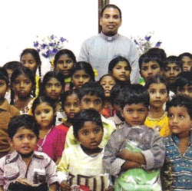

**To Selfless Self-sufficiency, NFP, Corporation**

**CHRISTS NFP**

**PO Box 135**

**Elmhurst, Illinois 60126**

christs.nfp@gmail.com

Yes! I would like, this year, to help these needy children in India

to become self-sufficient young adults helping others.

___ By a **Donation** or **Pledge.** ___ By **Prayer**

Name _______________________________________________________

Address______________________________________________________

City, State, Zip ________________________________________________

E-Mail ______________________________________

Phone______________________________________

I would like to support number ( ) of boys

( ) of girls

( ) of who needs it the most

At $240 per year per child (providing food, clothes, tuition, supplies, medical care, & board for the children).

( ) $240 per year per child

( ) I will provide my donation for the children in two $120.00 installments per child (by July & by January)

( ) I would like to receive a picture and a yearly update of my child (or children).

-OR-

( ) Enclosed is my donation for $_______________________

**CHRISTS NFP** is an IRS qualified 501(c)(3) charity & your **donations** are

**tax deductible** as allowed by the IRS code.

**100% of donations** to CHRISTS NFP Sponsor Account **goes for the children!**